TechOps Provider Support Documentation
This document will serve as a centralized, well-organized worksheet for common issues, how-to guides, tips, and troubleshooting steps to help associates support providers more independently.

Table of Contents
- Overview of TechOps Support Roles
- Common Issues & How-To Guides
  - Issue Template (for additions)
- Tips, Tricks, & Best Practices
- Process Workflows
- Reference Links & Tools

1. Overview of TechOps Support Roles
TechOps HelpDesk
Manager: Kelly Thompson
Contact Methods:
- Email: techopshelpdesk@locumtenens.com
- Phone: 877-732-7080 (Use primarily for provider support)
Areas Supported:
- LocumTenens.com Provider Portal technical issues
- Axuall credentialing technical errors
- Document Uploader issues
- SharePoint (provider-facing upload errors, permissions, access issues)
- Telehealth Technology
  - Equipment & hardware support
  - Connectivity, camera, audio, and laptop issues
- Kimedics technical issues
- Mobile App technical errors
- LTOE timesheet errors (technical only; not credentialing-related)
- Bitwarden
- Monday.com technical support

2. Common Issues & How-To Guides
Provider Cannot Open or Upload Documents
Description: Provider reports documents won’t open, downloads are blocked, or uploads fail.
Common Causes:
- Organization security restrictions on email or SharePoint
- VPN interference (provider potentially connected to VPN)
- Browser cache or outdated browser
Step-by-Step Resolution:
- Ask the provider to try opening or uploading the document in Google Chrome.
- Have them clear browser cache and retry. (How to)
- If connected to a VPN, disconnect temporarily and test again.
- Attempt the upload from a different device or network.
- If the issue persists and an error references organizational blocking, escalate for email/security review.
- Tip: Ensure the provider is uploading the document as an accepted file type (Documents must be in .pdf or .docx format. Headshots should be in .jpg, .png, or another accepted image format.)

Provider Not Receiving Emails (Invites, Codes, Links)
Description: Provider reports they are not receiving login codes, invites, or system emails.
Step-by-Step Resolution:
- Confirm the email on file in Salesforce is correct.
- Ask the provider to check Spam/Junk folders.
- Have them search for emails from LT_OnlineServices@locumtenens.com.
- Resend the invite or verification code.
- If still not received, recommend adding LT_OnlineServices@locumtenens.com to their safe sender list.

Clinician Portal Verification Confusion
Description: Provider believes they are credentialed or invited but cannot proceed.
Key Clarification:
- The LT Online Experience invite only verifies the account.
- It does not start the credentialing process.
Correct Next Step:
- Provider must follow the How to Access the Credentialing Application instructions to begin credentialing in Axuall.

Mobile Credentialing Access Error
Description: A known issue occurs when providers attempt to complete the credentialing process on a mobile device.
Symptoms:
- Provider navigates to Credentials → Credentialing Overview on their phone.
- They receive the error message: “Oh no, something is definitely broken.”
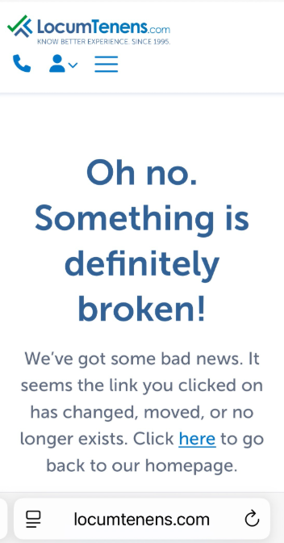
Important Note:
- Nothing is actually broken — this is a known mobile compatibility issue.
Workaround:
- Providers can access the credentialing application on their phone using the direct credentialing link:
https://portal.locumtenens.com/#/credentials/overview
Best Practice Recommendation:
- If possible, encourage providers to complete credentialing on a desktop or laptop for the most reliable experience.

Incorrect Username or Password Error
Description: Steps to resolve login errors related to incorrect username or password when accessing the provider’s LTOE account.
How to Reset the Password:
- On the login screen, click Forgot your password?
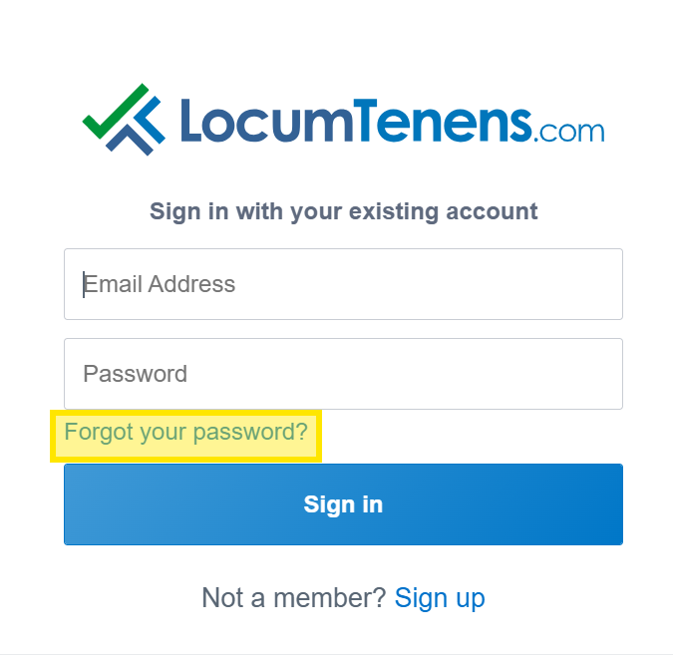
- Enter the email address associated with the account.
- Enter the verification code sent to that email.
- Create a new password that meets all listed requirements.
- Log in using the newly created password.
Important Note:
- If a provider’s account is locked, TechOps cannot unlock it manually.
- Resetting the password will automatically unlock the account, OR the provider may wait 30 minutes for the lock to clear on its own.

Missing Credentials Tab
Description: Reasons a provider may not see the Credentials tab in their LTOE account and how to validate their account configuration.
Common Causes
- LTOE username and Salesforce email do not match
  - These two fields must match for proper credentialing access.
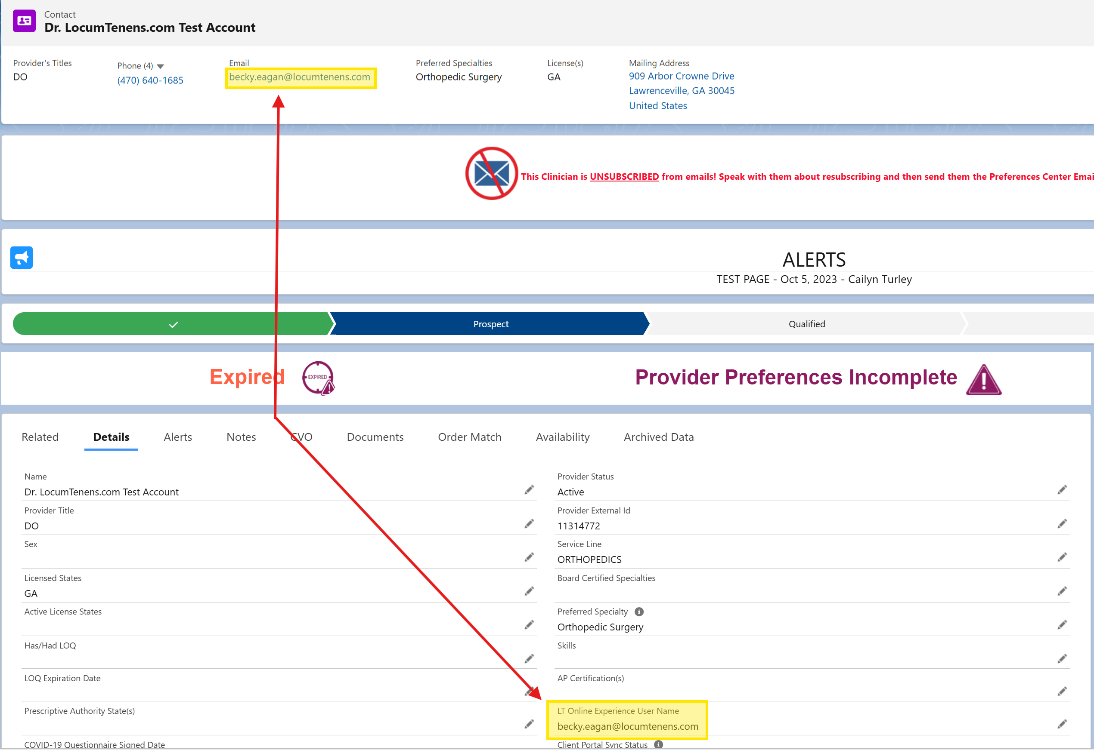
  - Note: Providers may still be able to log in even if they do not match, but this often results in system glitches or missing functionality.
- Clinician Portal is not verified
  - An unverified portal can prevent the Credentials tab from appearing.

How to Check a Provider’s LTOE Username
- Open the provider’s record in Salesforce.
- Click the Details tab.
- Locate the LTOE Username field.
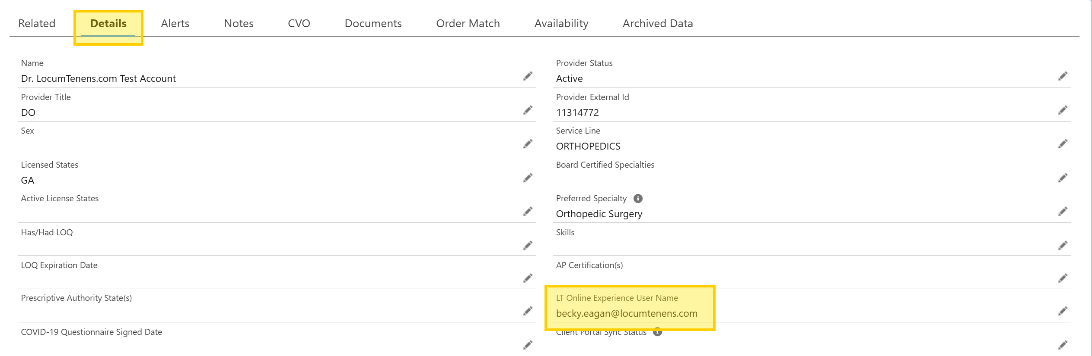
Important: The provider’s email and LTOE username must match to ensure the account functions correctly.

How to Check Clinician Portal Verification Status
- Go to the provider's Salesforce page.
- Select the Details tab.
- Scroll to the bottom until you find Clinician Portal Verification.
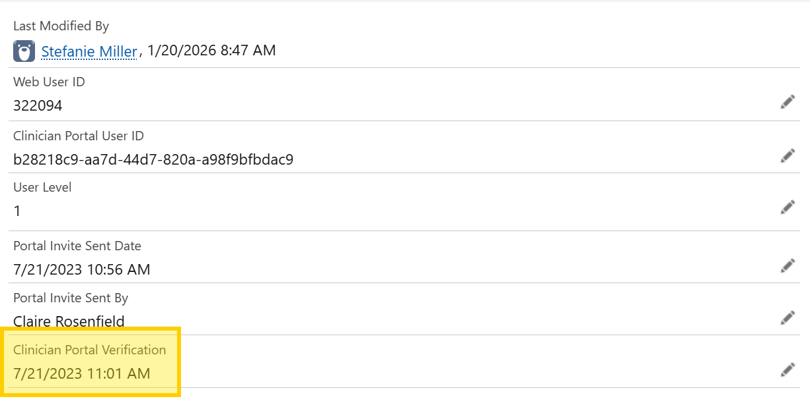

Critical Notes
- A provider’s email in Salesforce CANNOT be changed if their portal is already verified.
A ticket must be submitted to LT Helpdesk (lthelpdesk@locumtenens.com) to request this change.
- Inviting the provider to the LT Online Experience does NOT send them the credentialing link.
The invite only allows them to verify their account — it does not initiate credentialing.
To begin credentialing, they must follow the steps outlined in the How to Access the Credentialing Application section.

Accessing the Credentialing Application
Description: Guide for providers to access their credentialing application through LTOE and Axuall.
Step-by-Step Instructions:
- Log in to your LTOE account at https://www.locumtenens.com/.
- Click the Log In button.
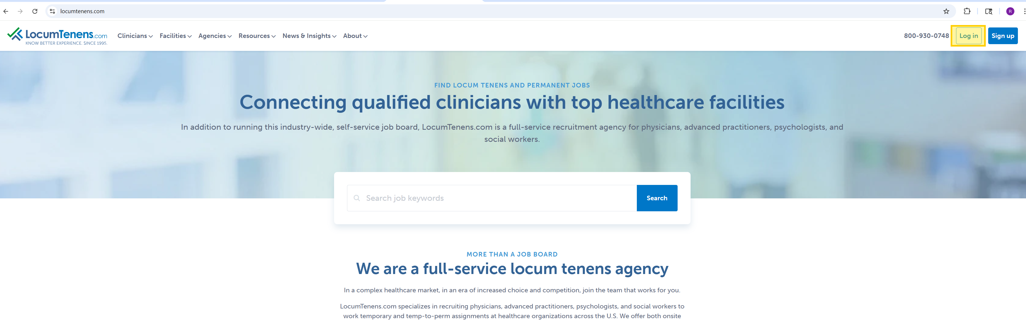
- Enter the email address on file (provider’s email in Salesforce) and the associated password.
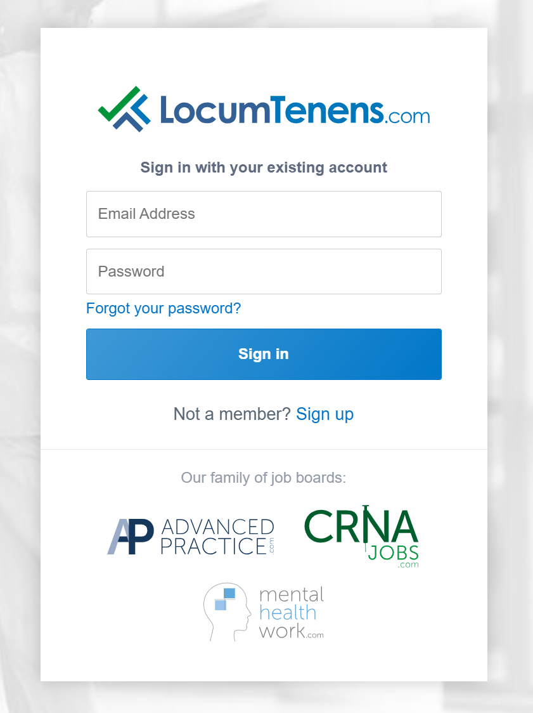
- Once logged in, click on CREDENTIALS.
- Select Credentialing Overview.
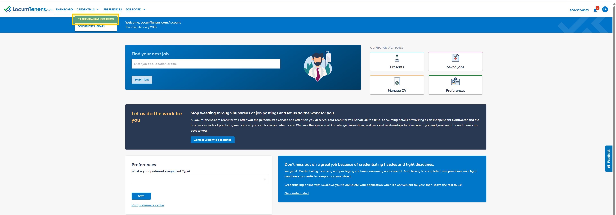
- You will see one of the following prompts:
  - Before you begin credentialing, please gather the following information: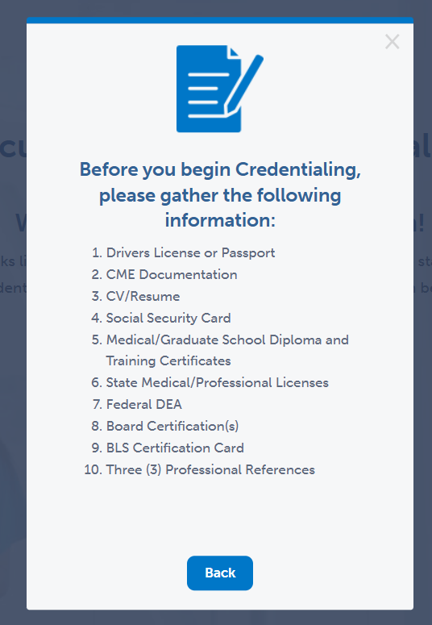
  - Verify your NPI number and click Get Started, or
  - Click Authenticate your account.
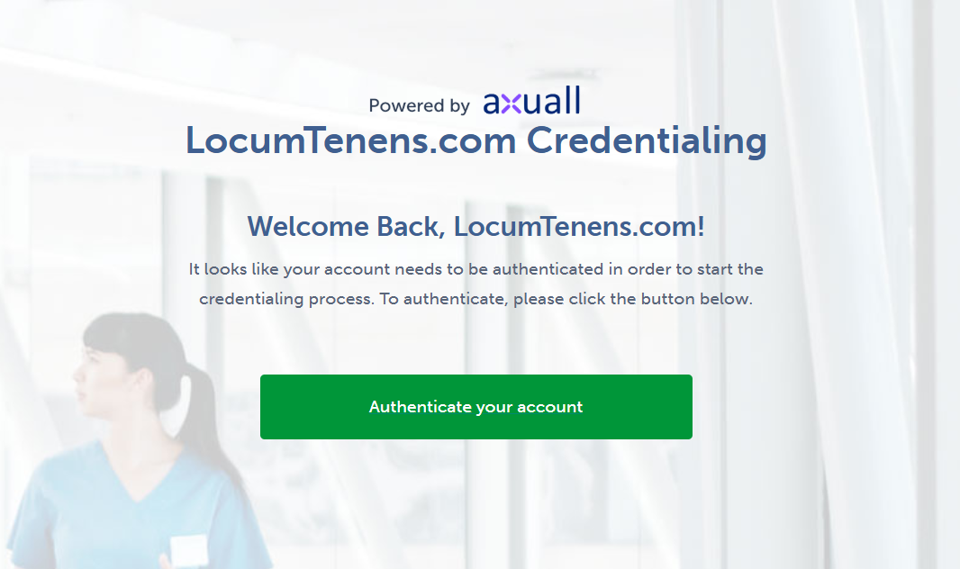
- You will then be automatically redirected to begin your credentialing application in Axuall.
Troubleshooting Tips:
- Try a different browser: Google Chrome is recommended and often resolves most access issues.
- Clear your browser cache: This can fix slow loading, blank screens, or looping behavior. (How to)
- Enable third-party cookies: Axuall requires these to function properly. (How to)
- Try another device: Attempt access using a laptop, desktop, smartphone, or tablet.

How To Re-Credential
Description: Guide for providers to access their re-cred application through LTOE and Axuall.
Step-by-Step Instructions:
- Log in to your LTOE account at https://www.locumtenens.com/.
- Click the Log In button.

- Enter the email address on file (provider’s email in Salesforce) and the associated password.

- Once logged in, click on CREDENTIALS.
- Select Credentialing Overview.

- Select Start my re-credentialing application
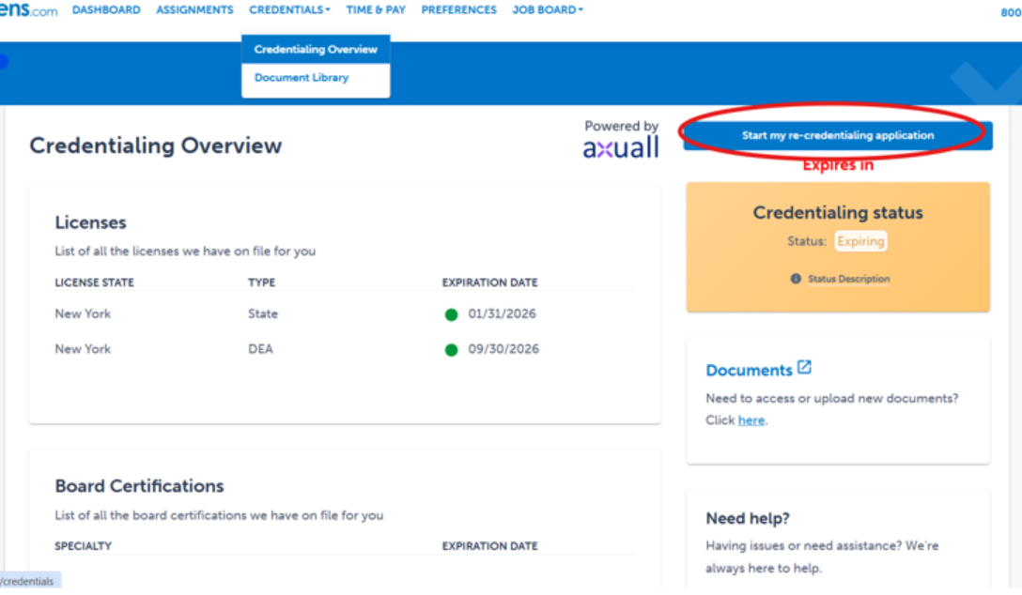
- You will then be automatically redirected to begin your credentialing application in Axuall.
Troubleshooting Tips:
- Try a different browser: Google Chrome is recommended and often resolves most access issues.
- Clear your browser cache: This can fix slow loading, blank screens, or looping behavior. (How to)
- Enable third-party cookies: Axuall requires these to function properly. (How to)
- Try another device: Attempt access using a laptop, desktop, smartphone, or tablet.

Axuall Identity Verification Error
What It Is: The Identity Verification error in Axuall occurs when a provider cannot successfully complete the identity verification step during credentialing or re-credentialing. This step is required to verify the provider’s identity before Axuall allows access to the credentialing workflow.
When this fails, the provider is blocked from moving forward — even if everything else appears correct.
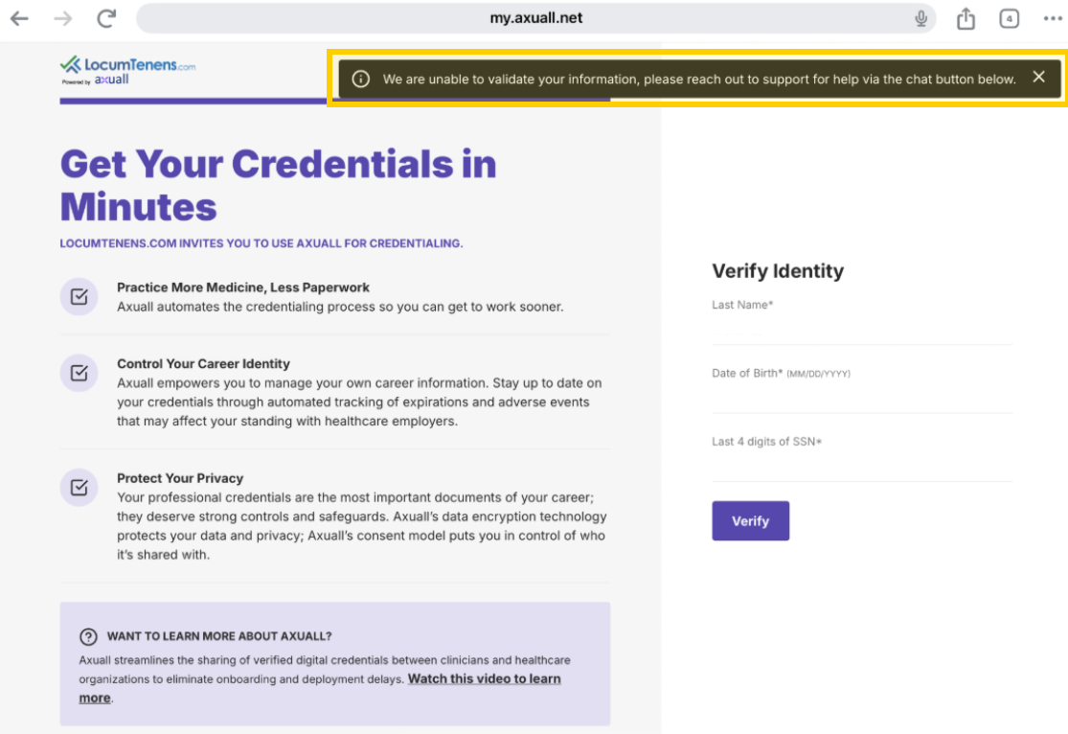
Common Error Messages / Symptoms: Providers may report:
- “Identity verification failed”
- “We were unable to verify your identity”
- Being looped back to the identity verification screen
Most Common Root Causes:
- Name Mismatch
  - The name entered in Axuall does not exactly match the provider’s government-issued ID.
  - Common causes include:
    - Middle name vs. middle initial
    - Married name vs. maiden name
    - Hyphenated last names
    - Suffixes (Jr., Sr., III) included or excluded
  - Important: Axuall is extremely literal — even minor discrepancies can cause the verification to fail.
- DOB or SSN Mismatch
  - Date of birth entered incorrectly in Axuall
  - Social Security Number mismatch (often due to a typo or transposed numbers)
  - Provider unsure which information was previously entered
Resolution / Required Next Steps:
- Because this issue involves sensitive personal information (legal name, DOB, SSN), LocumTenens cannot make corrections or verify details on the provider’s behalf.
- The provider must contact Axuall Support directly to securely verify and correct their information.
Axuall Support Phone Number:
888-298-1730
Axuall Support is the only party authorized to assist with identity verification issues.
Escalation Path:
- If Axuall Support is unable to assist or the provider continues to experience identity verification issues after contacting Axuall, escalate to: TechOpsHelpdesk@locumtenens.com

Document Library — What It Is & What It Does
Definition:
The Document Library is a centralized repository where all provider-related documents are stored, organized, and managed.
Important Usage Notes:
- The Document Library is intended for uploading additional documents after the credentialing application has been completed.
- Documents uploaded before the credentialing application is finished will not appear in Axuall.
- If a provider has not credentialed with LocumTenens.com, they will not be able to access the Document Library.
- In this scenario, LTOE will automatically redirect the provider to the Credentialing Overview tab so they can proceed to Axuall and complete credentialing.
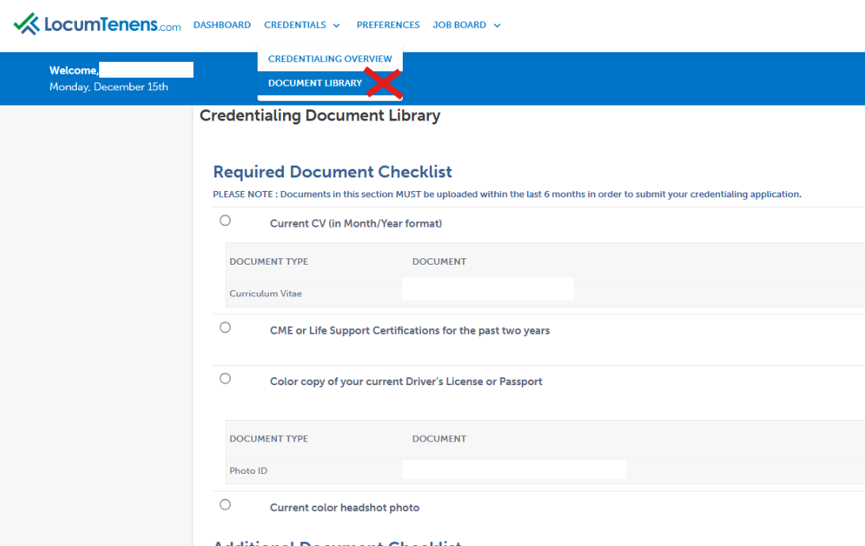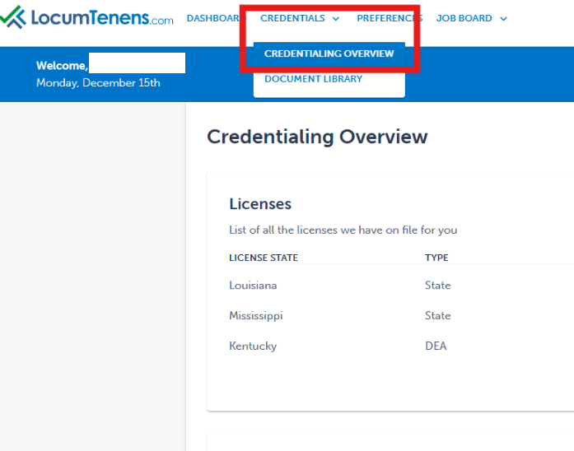

Credentialing Overview — What It Is & Why It Matters
Definition:
Credentialing is the formal process of verifying a practitioner’s professional qualifications, training, licenses, and competence to practice or provide services.
- Credentialing uses the documents stored in the Document Library to validate a provider’s eligibility to work.

Relationship Between Document Library & Credentialing
Think of it this way:
- The Document Library is the filing cabinet
- Credentialing is the audit and verification process
How they work together:
- Document Library: Collects and organizes required paperwork
- Credentialing: Reviews and verifies those documents against required standards and rules
Important Clarification:
- You cannot complete credentialing without the required documents.
- Having documents in the Document Library does not mean a provider is credentialed.

Common Provider Confusion & Troubleshooting
Providers may report:
- They completed the application, but their status still shows Application Started or Application Sent
- They are unable to upload documents
- Documents they uploaded are not appearing in Axuall
Recommended Next Step:
- If the provider cannot be found in the Axuall Admin Center, request a screenshot of what they are seeing.
- This helps determine whether the provider is:
  - Still completing the credentialing application in Axuall, or
  - Attempting to upload documents in the Document Library before credentialing is complete.

The provider reports information is not pre-populating on their credentialing application.
What Axuall Typically Pre-Populates for LocumTenens.com
Axuall is primarily used to auto-pull primary source data from verified databases. The following information is commonly auto-populated:
1. Primary Source Licenses
- State license status
- Expiration date
- Board/certifications
- DEA (when applicable)
These fields usually come through automatically because Axuall pulls them from verified databases.
2. Certifications
- BLS / ACLS / PALS (if applicable)
- Other board certifications
These can auto-populate because they’re often tied to credentialing boards.
3. Identity & Demographics (Once Verified)
- Name
- DOB
- NPI (when verified)
- Basic demographic details
These are commonly auto-filled after identity verification.

What Axuall Does Not Pre-Populate (LocumTenens.com Use Cases)
The following information typically does not auto-populate and must be manually entered by the provider:
Personal Contact Info
- Preferred phone number
- Preferred email
- Home address vs mailing address
Attestation / Self-Reported Questions Anything that requires a clinician to attest is manual, including:
- “Have you ever been disciplined?”
- “Have you ever been convicted?”
- Malpractice history explanations
- Anything that needs a signature
Axuall can store this, but it doesn’t auto-populate because it’s personal and subjective.
Narrative Answers Any text-based explanation fields:
- “Explain this gap”
- “Explain this claim”
- “Provide details about this incident”
These do not auto-populate and must be manually entered.

What Often Partially Pre-Populates
Some fields are suggested or partially pulled but still require clinician confirmation or correction:
Employment History Axuall may suggest prior employment based on available data, but:
- Dates may be incorrect
- Roles may need editing
- Facility names may be incomplete
Facility Affiliations Axuall may pull affiliations, but it’s not always perfect.

Why Axuall Doesn’t Auto-Populate Everything
Axuall pulls from primary sources and verified databases, but not from subjective clinician-provided information. Anything that requires self-attestation, personal preference, or narrative explanation will not be auto-filled.

Use the template below when submitting a ticket to TechOpsHelpdesk.
Provider Name:
Issue Description:
SF Link:
Screenshots:

3. Tips, Tricks, & Best Practices
Credentialing Document Sync Timing
- Credentialing documents can take up to 24 hours to sync from Axuall to Salesforce.
This delay is normal and should be expected before reporting missing documents or opening a support case.

